សាកលវិទ្យាល័យភូមិន្ទភ្នំពេញ

**Royal University of Phnom Penh**

មហាវិទ្យាល័យវិស្វកម្ម

**Faculty of Engineering**

ដេប៉ាតឺម៉ង់ វិស្វកម្មទូរគមនាគមន៍និង​អេឡិចត្រូនិច

Department of Telecommunication and Electronic Engineering

**Smart Pet Feeding**

**Components report**

**Group 12**

**Soun Kimhour**

**Saing Lymchhun**

**February 2023**

**Table of Contents**

1. **Components** 
   1. **ESP32-WROVER-IE**
   2. **Stepper Motor**
   3. **SG90 Micro-servo motor**
2. **Components**

**1.1 ESP32-WROVER-IE**

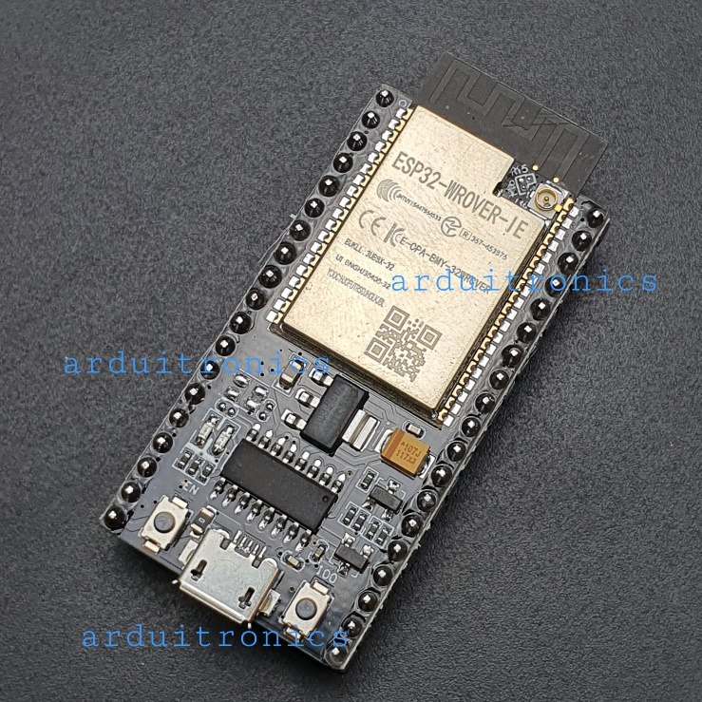

* 1. **Stepper Motor**

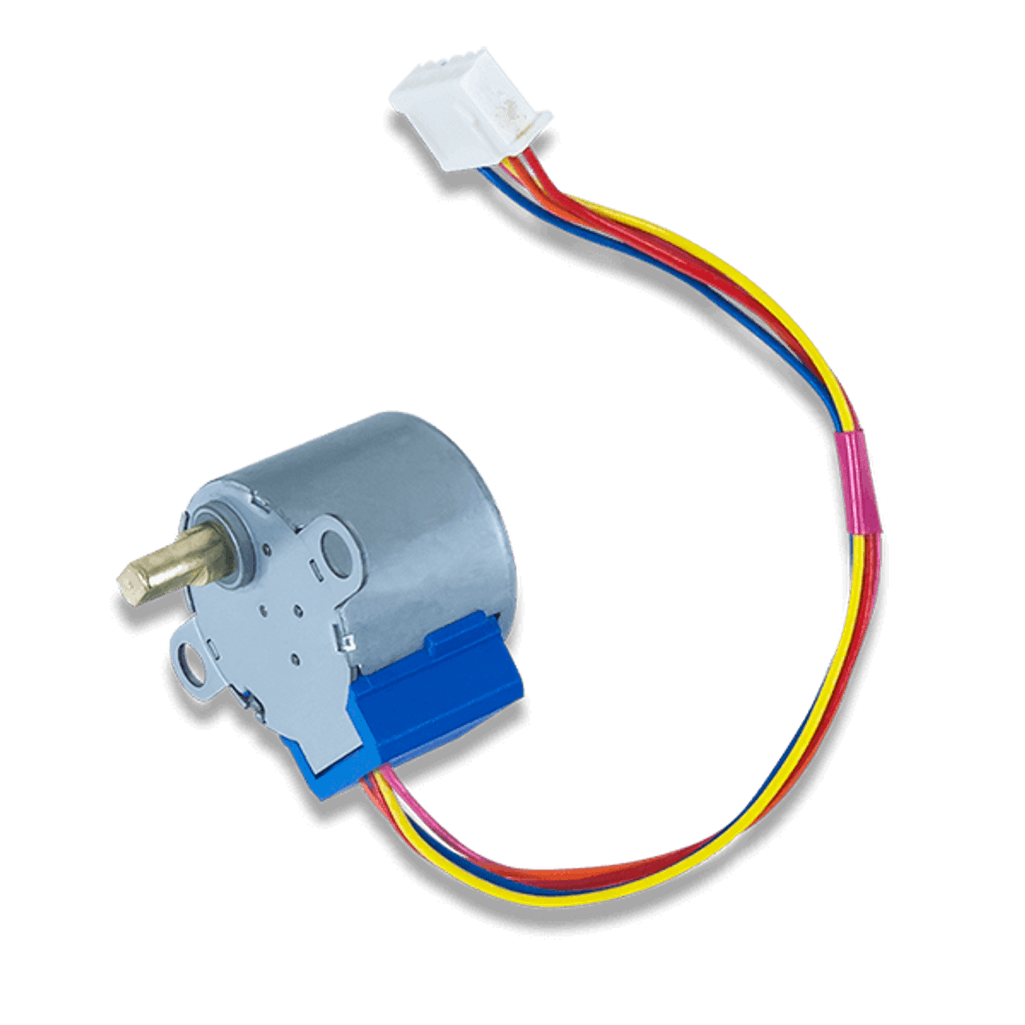

* 1. 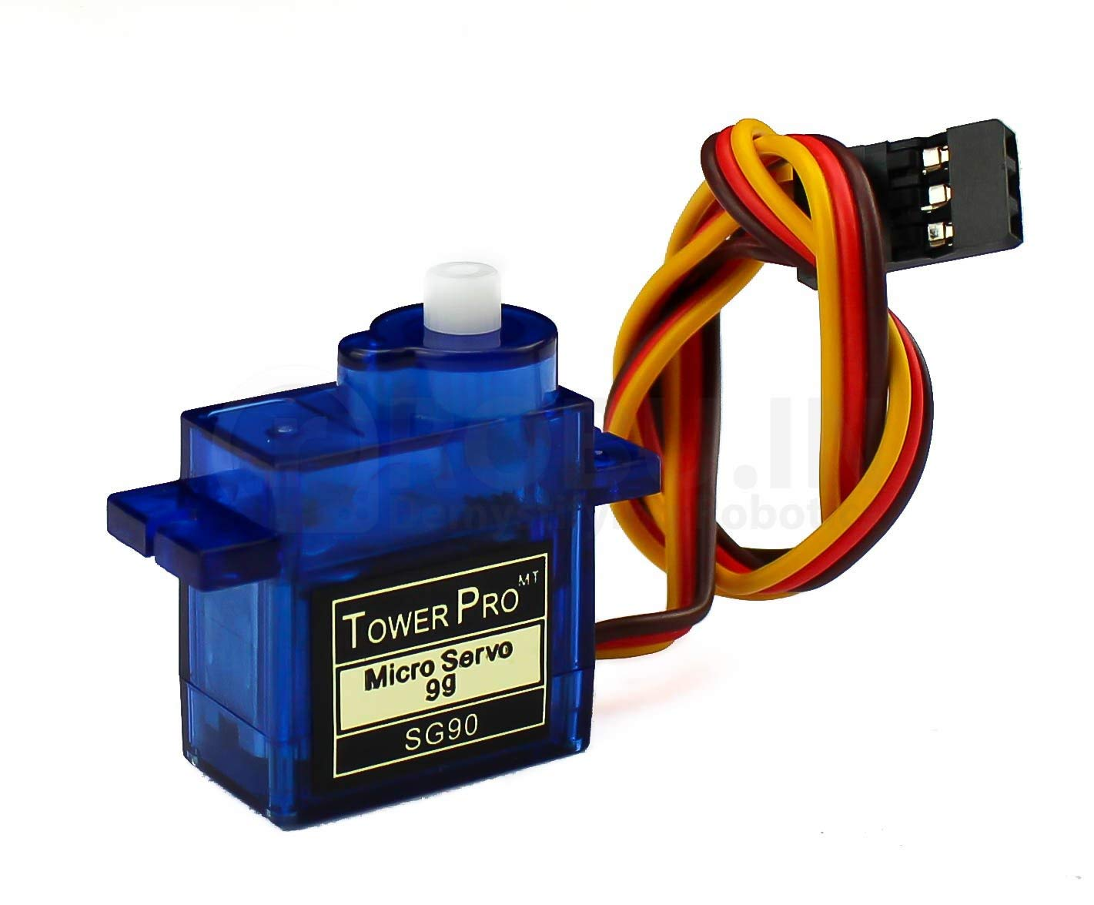 **SG90 Micro-servo motor**